London Modern Quilt Guild
HST 2020 Block of the Month - July
For July, we will again provide layouts for 2 blocks of our quilt.
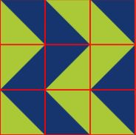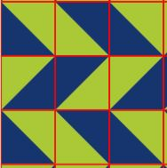
Have you been playing with the layout on your design wall? It is so interesting to see secondary designs emerge from the versatile HST blocks.
July BOM – strip tube half square triangles. This is a two-block month.
There is a specialty ruler that you can use with this method – check with your local quilt store if you want to add to your ruler collection.
- Cozy Quilt Designs Strip Tube Ruler – their guide to using this ruler: https://cozyquilt.com/PDFs/STRBonusGuide.pdf
- Any square or rectangular ruler with a 45◦ marked angle. Quiltinerring has this great tutorial:
http://www.quiltineering.com/hst-tutorial-strip-tube-method/

For our two blocks this month, you will need 18 HST.
Before getting out the rotary cutter, choose your favorite starching/sizing product. Prepare your fabric according to the directions before cutting. This method creates bias edges so pre-treating the fabric is highly recommended. Work carefully with bias edges – don’t press or pull them out of shape.
Use the following chart to cut the width of fabric strips (one of each contrasting colour) for your tubes:
Finished HST size  (sewn into the block) | Cut size (HST before sewing into block) | Width of tube | Triangles per WOF strip tube: # WOF strips needed for 18 HST
3 inches | 3 ½” | 3 ¼” | 14 : 2
4 inches | 4 ½” | 4” | 10 : 2
5 inches | 5 ½” | 4 ¾” | 8 : 3
6 inches | 6 ½” | 5 ½” | 7 : 3
7 inches | 7 ½” | 6 ¼” | 6 : 3
8 inches | 8 ½” | 7” | 5 : 4
9 inches | 9 ½” | 7 ½” | 4 : 5

- Cut your fabrics WOF – salvage to salvage (see table for how many you need) for each colour
- Place your contrasting fabrics right sides together
- Sew a seam ¼” on both the upper and lower edge of the strip. This creates a tube.
- I find it helpful to put a piece of washi tape or painter’s tape or frog tape on the ruler so I place my ruler at the correct spot for each cut.
- Place your ruler on the tube so that you are lining up the bottom SEAM line in your tube.
- Using your rotary cutter, slice the tube following the ruler – be extra careful on the cut from top to bottom as you are cutting towards yourself.
  - When I’m doing this method I cut all the way from the bottom of the tube to the top of the tube.
- This is an example of a square ruler placement for a 2 ½” unfinished HST.

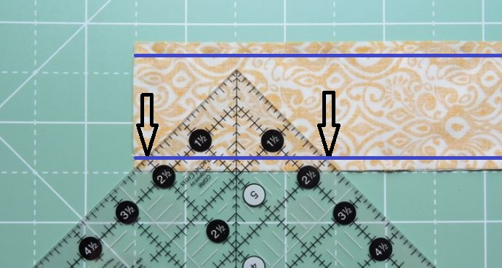

- For the next HST, rotate your ruler to line up the markings on the top seam line.
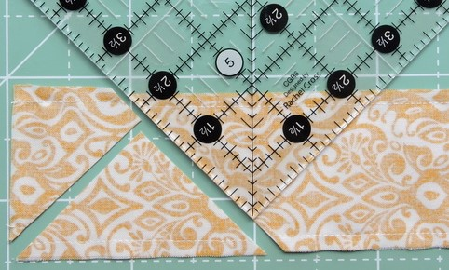
- Press your HST open, and trim to perfection
- Arrange your HST into this month’s blocks

These blocks are being released in random order. Consider creating a project box for them to rest in rather than sewing everyone together. Full layout will be released in later in the year. So far, we have 10 of our 12 blocks released, as well as a bonus block.
Have fun sewing.

